**George Lamming (1927— )**

George Lamming’s fiction, poetry, criticism, and journalism have been foundational for twentieth-century Caribbean and African diasporic identities. To date, he is the author of six loosely connected novels, and is arguably best known for *In the Castle of My Skin* (1953), *The Emigrants* (1954), and his widely-read critical work, *The Pleasures of Exile* (1960). In these and other texts, Lamming critiques colonial rule and European hegemony on their own terms through recurring themes such as language, Shakespeare’s *The Tempest*, and Christopher Columbus, and through an elliptical narrative style that experiments with point of view, temporality, and dialect as alternative strategies of representation.

Born in Carrington Village, Barbados, in 1927, Lamming briefly moved to Trinidad before becoming one of thousands of West Indians to relocate to post-war England. After settling in London in 1950, he worked for *Caribbean Voices*, a BBC radio programme that provided a platform for displaced West Indian writers during the 1940s and 1950s. The programme helped Lamming secure a contract for his first novel, *In the Castle of My Skin*, which was published in 1953 to almost immediate international success. Based on his own early life, the novel centres on the childhood, colonial education, and young adulthood of ‘G.’ Lamming enlists a large cast of characters to chronicle life in a village that will dissolve when its black residents lose their homes to unjust backroom politics. Yet leaving colonial Barbados will allow G. to discover a broader, African diasporic identity unknown there.

Lamming again drew upon personal experiences for his second novel, *The Emigrants*, to present a group of West Indians from every part of the Caribbean as they travel to and arrive in England. The narrative juxtaposes a restless and hopeful voyage with experiences of racism, marginality, and isolation in London. In *Water with Berries* (1971), Lamming returned to the difficulties facing West Indian immigrants in England, but his other novels—*Of Age and Innocence* (1958), *Season of Adventure* (1960), and *Natives of My Person* (1972)—concern San Cristobal, a fictional Caribbean island whose colonial history and struggle for independence reflect the region in miniature.

Lamming’s major nonfiction work, *The Pleasures of Exile*, inventively borrows from travel writing, literary criticism, political thought, social theory, and autobiography to consider a range of literary-cultural issues, such as how the novel form can explore West Indian subjectivity and social life; the decision of Caribbean writers of Lamming’s generation to live abroad; and unlearning a colonial education that privileges English literature and culture. *The Pleasures of Exile* also articulates the brand of politics Lamming would later practice as a participant in the revolutionary movements of the 1960s and 1970s in Guyana, Trinidad, Barbados, and in the Civil Rights Movement in the United States.

A significant figure in contemporary British and Anglophone literary and cultural history, Lamming continues to write, travel, lecture, give interviews, and teach (most recently at Brown University). An excerpt from a novel-in-progress, *Columbus: A View from the Other Side*, recently appeared in *The George Lamming Reader*.

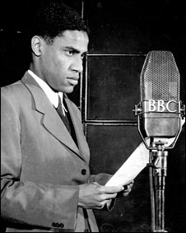

Figure 1: George Lamming (date unknown)

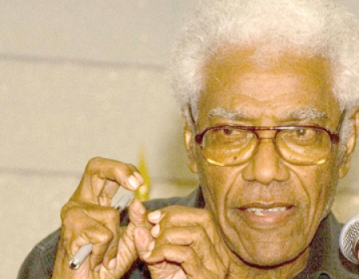

Figure 2: Lamming in 2010

***Books by Lamming***

*In the Castle of My Skin* (1953)

*The Emigrants* (1954)

*Of Age and Innocence* (1958)

*Season of Adventure* (1960)

*The Pleasures of Exile* (1960; nonfiction)

*Water with Berries* (1971)

*Natives of My Person* (1972)

Editor, *Canon Shot and Glass Beads: Modern Black Writing* (1974)

***Interviews***

Drayton, R. and Andaiye, (eds) (1992), *Conversations: George Lamming: Essays, Addresses, and Interviews, 1953-1990*. London: Karia Press.

*Coming, Coming Home: Conversations II: Western Education and the Caribbean Intellectual* (1995). Philipsburg, St. Martin: House of Nehesi.

*The Sovereignty of the Imagination: Conversations III: Language and the Politics of Ethnicity* (2009). Philipsburg, St. Martin: House of Nehesi.

***References and Further Reading***

BBC’s web page for its documentary on *Caribbean Voices*. [http://www.bbc.co.uk/worldservice/ documentaries/2009/07/090721_caribbean_voices_1.shtml](http://www.bbc.co.uk/worldservice/%20documentaries/2009/07/090721_caribbean_voices_1.shtml)

Bogues, A. (ed) (2011), *The George Lamming Reader: The Aesthetics of Decolonisation*. Ian Randle: Kingston and Miami.

Brown, J. D. (2006) ‘Exile and Cunning: The Tactical Difficulties of George Lamming,’ *Contemporary Literature* 47 (4): 669-694.

Gikandi, S. (1992) *Writing in Limbo: Modernism and Caribbean Literature*, Ithaca, NY and London: Cornell University Press.

Kalliney, P. (2007) ‘Metropolitan Modernism and Its West Indian Interlocutors: 1950s London and the Emergence of Postcolonial Literature,’ *PMLA* 122 (1): 89-104.

Nair, S. (1996) *Caliban’s Curse: George Lamming and the Revisioning of History*, Ann Arbor: University of Michigan Press.

Ngũgĩ wa Thiong’o (1972) *Homecoming: Essays on African and Caribbean Literature, Culture, and Politics*, London, Ibadan, and Nairobi: Heinemann.

Paquet, S. P. (1982) *The Novels of George Lamming*, London: Heinemann.

Silva, A. J. S. da (2000) *The Luxury of Nationalist Despair: George Lamming’s Fiction as Decolonizing Project,* Amsterdam and Atlanta: Rodopi.

======================

***Permissions needed for this entry***

1. Figure 1 appears on BBC’s web page for their documentary on *Caribbean Voices* < <http://www.bbc.co.uk/worldservice/documentaries/2009/07/090721_caribbean_voices_1.shtml> >.
2. Figure 2 appears on the web site of the Barbadian newspaper *Nation News*: < <http://www.nationnews.com/articles/view/Lamming-lashes-political-parties/> >.